<!DOCTYPE html>

<html lang="en">

<head>

    <meta charset="UTF-8">

    <meta http-equiv="X-UA-Compatible" content="IE=edge">

    <meta name="viewport" content="width=device-width, initial-scale=1.0">

    <title>login page</title>

</head>

<link rel="stylesheet" href="style.css">

<body>

    <div class="login-form">

        <h1>Login Here</h1>

        <form>

            <img src="images.png"

        <p>Email</p>

        <input type="text" name="email" placeholder="enter your email">

        <p>Password</p>

        <input type="password" name="password" placeholder="enter your password">

        <input type="button" name="submit" value="login">

        <a href="#">forget password</a>

          </form>

        </div>

</body>

</html>

body{

    margin:0;

   padding: 0;

   background: url("img.jpg");

   background-size: cover ;

   font-family:  sans-serif;

   color: red ;

}

.login-form{

    background-color: rgba(0, 0,0, .6);

    width: 380px;

    height: 350px;

    margin:0 ;

    padding: 35px;

    position:absolute;

    top: 50%;

    left: 50%;

    box-sizing: border-box;

    transform: translate(-50%,-50%);

}

h1{

margin: 0;

padding:0;

font-weight: bold;

text-align: center;

}

p{

    margin: 0;

    padding: 0;

    font-size: 18px;

}

input{

    width: 100%;

    margin-bottom: 28px;

}

.login-form input[type="text"], input[type="password"]

{

    border: none;

    border-bottom: 1px solid #fff;

    background: transparent;

    outline: none;

    height: 35px;

    font-size: 18px;

    color: white;

}

.login-form a{

    text-decoration: none;

    color: #fff;

    font-size: 18px;

}

.login-form input[type="button"]:hover

{

    border: none;

    outline: none;

    background-color: #000;

    height: 40px;

    color: white;

    cursor: pointer;

border-radius:20px ;

font-size: 18px;

}

.login-form img{

    width: 100px;

    height: 100px;

    position: absolute;

    top: -60px;

    left: calc(50% - 50px);

}

Screen shot

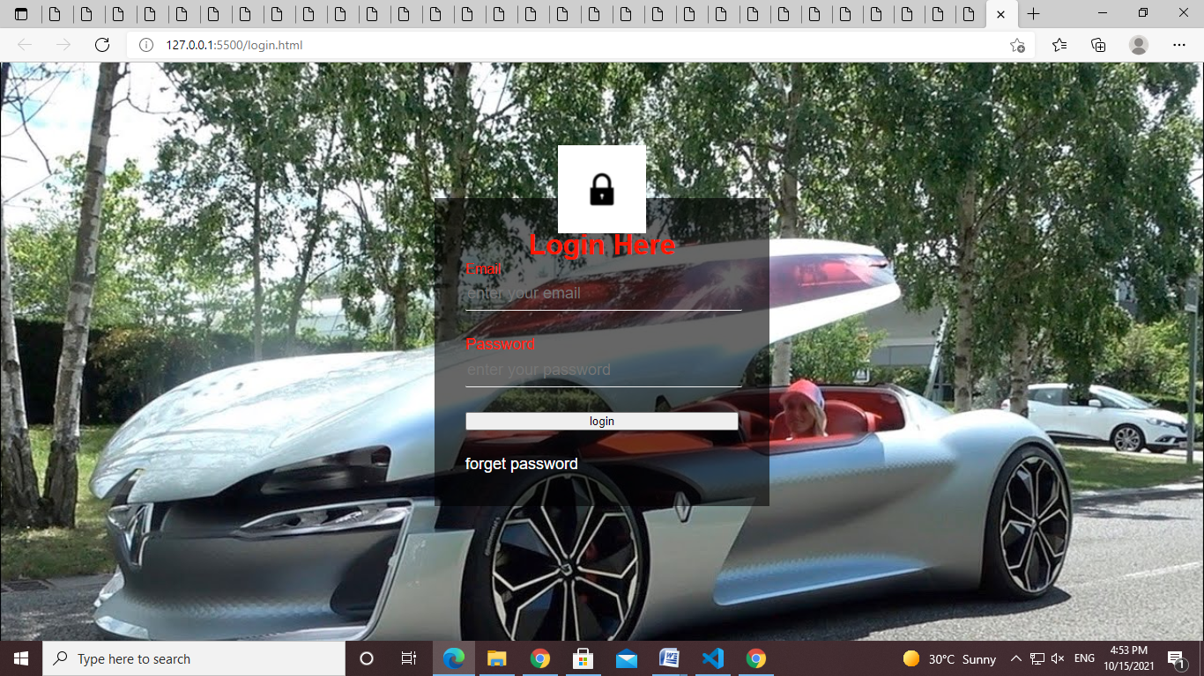

<!DOCTYPE html>

  <html>

  <head>

  <meta charset="utf-8">

  <title>Style Placement</title>

  <link rel="stylesheet" href="style.css">

  <style>

  h2 {

    color: maroon;

  }

  </style>

  </head>

  <body>

  <h1>Style Placement</h1>

  <h2>Subheading 1</h2>

  <p>Lorem ipsum dolor sit amet, consectetur adipisicing elit. Ex et similique cupiditate dignissimos delectus nulla dolore, eos dolorum quidem excepturi, facere non repellat accusamus, atque? Id voluptate eos et accusantium.</p>

  <h2>Subheading 2</h2>

  <p style="text-align: center;">I am centered!</p>

  </body>

  </html>

  Â© 2021 GitHub, Inc.

  --------------------------------------------------------

  p {

    font-size: 130%;

    background-color: gray;

    color: white;

  }

  --------------------------------------------------------

  <!DOCTYPE html>

  <html>

  <head>

  <meta charset="utf-8">

  <title>Inheritance in CSS</title>

  <style>

  body {

    color: red;

    text-align: center;

    font-family: Helvetica;

  }

  p {

    color: blue;

  }

  </style>

  </head>

  <body>

  <h1>Cascade of CSS Example</h1>

  <h2>Subheading 1</h2>

  <p>Inheritence allows us to write more global styles on parent elements and then "fine-tune" the styles for some of the child elements as needed. Such approach makes writing CSS very efficient.</p>

  <h2 style="color: green;">Subheading 2</h2>

  <p>Lorem ipsum dolor sit amet, consectetur adipisicing elit. Architecto ad excepturi eveniet odio, fuga nam quidem reprehenderit placeat commodi? In laudantium cum nam quod vitae at eligendi consequatur sequi cumque.</p>

  </body>

  </html>

  ------------------------------------------------------------------------

  <!DOCTYPE html>

  <html>

  <head>

  <meta charset="utf-8">

  <title>Cascade of CSS</title>

  <link rel="stylesheet" href="external.css">

  <style>

  p {

    color: maroon;

  }

  </style>

  </head>

  <body>

  <h1>Origin Example</h1>

  <p>The rule is simple: last declaration wins.</p>

  <p style="color: black;">If there is no conflict, declarations merge into one rule.</p>

  </body>

  </html>

  ---------------------------------------------------------

  <!DOCTYPE html>

  <html>

  <head>

  <meta charset="utf-8">

  <title>Inheritance in CSS</title>

  <style>

  header.navigation p {

    color: blue;

  }

  p.blurb {

    color: red;

  }

  p {

    color: green !important;

  }

  </style>

  </head>

  <body>

  <header class="navigation">

    <p class="blurb">Lorem ipsum dolor sit amet, consectetur adipisicing elit. Vero soluta enim aut! Nihil nam obcaecati, fugiat sint sit libero voluptate eos incidunt odio neque cum, dignissimos aperiam, magnam nisi debitis.</p>

  </header>

  </body>

  </html>

  ------------------------------------------------------------

  ---------------------------------------------------------

  <!DOCTYPE html>

  <html>

  <head>

  <meta charset="utf-8">

  <title>Styling Text</title>

  <style>

  .style {

    font-family: Arial, Helvetica, sans-serif;

    color: #0000ff;

    font-style: italic;

    font-weight: bold;

    font-size: 24px; /* points (pt) are used in print, not screen.*/

    text-transform: uppercase;

    text-align: right;

  }

  </style>

  </head>

  <body>

  <p>You can get commonly used font combinations from <a href="http://www.w3schools.com/cssref/css_websafe_fonts.asp">http://www.w3schools.com/cssref/css_websafe_fonts.asp</a>. Lorem ipsum dolor sit amet, consectetur adipisicing elit. Quisquam quod necessitatibus a ullam dolorum amet reprehenderit sit laudantium reiciendis aperiam. </p>

  <p class="style">Lorem ipsum dolor sit amet, consectetur adipisicing elit. Laboriosam fugiat repudiandae fugit porro commodi amet possimus sit atque, non obcaecati, et repellendus enim perferendis nobis quibusdam vero nulla magni quaerat!</p>

  </body>

  </html>

  --------------------------------------------------------

  <!DOCTYPE html>

  <html>

  <head>

  <meta charset="utf-8">

  <title>Setting Font Size</title>

  <style>

  body {

    font-size: 120%;

  }

  </style>

  </head>

  <body>

  <div>Regular text</div>

  <div style="font-size: 2em;">2em text

    <div style="font-size: 2em;">4em text

      <div style="font-size: .5em;">2em again!</div>

    </div>

  </div>

  </body>

  </html>

  ---------------------------------------------------------

  <!DOCTYPE html>

  <html>

  <head>

  <meta charset="utf-8">

  <title>The Box Model</title>

  <style>

  * {

    box-sizing: border-box;

    margin: 0;

    padding: 0;

  }

  body {

    background-color: gray;

  }

  #box {

    background-color: blue;

    padding: 10px;

    border: 5px solid black;

    width: 300px;

    height: 50px;

    margin-top: 50px;

    overflow: auto;

  }

  #content {

    background-color: #90EE90; /* green */

  }

  h1 {

    margin-bottom: 30px;

  }

  </style>

  </head>

  <body>

  <h1>Box Model</h1>

  <div id="box">

    <div id="content">Lorem ipsum dolor sit amet, consectetur adipisicing elit. Suscipit error quis ab perspiciatis eos inventore recusandae iste itaque numquam facilis, tenetur. Doloribus officiis quae facilis, nisi, ex similique. Animi, perferendis.

    </div>

  </div>

  </body>

  </html>

  --------------------------------------------------

  <!DOCTYPE html>

  <html>

  <head>

  <meta charset="utf-8">

  <title>Background</title>

  <style>

  #bg {

    width: 500px;

    height: 500px;

    background: url('yaakov.png') no-repeat top center;

    background-color: blue;

  }

  </style>

  </head>

  <body>

  <div id="bg">Background properties are fun!</div>

  </body>

  </html>

  ----------------------------------------------------

  <!DOCTYPE html>

  <html>

  <head>

  <meta charset="utf-8">

  <title>Two Column Design</title>

  <style>

  * {

    box-sizing: border-box;

  }

  div {

    /*background-color: #00FFFF;*/

  }

  p {

    width: 50%;

    /*border: 1px solid black;*/

    float: left;

    padding: 10px;

  }

  #p1 {

    /*background-color: #A52A2A;*/

  }

  #p2 {

    /*background-color: #DEB887;*/

  }

  section {

    clear: left;

  }

  </style>

  </head>

  <body>

  <h1>Two Column Design</h1>

  <div>

    <p id="p1">Lorem ipsum dolor sit amet, consectetur adipisicing elit. Quia distinctio aliquid cupiditate perferendis fuga, sit quasi alias vero sunt non, ratione earum dolores nihil! Consequuntur pariatur totam incidunt soluta expedita.</p>

    <p id="p2">Lorem ipsum dolor sit amet, consectetur adipisicing elit. Dicta beatae voluptatibus veniam placeat iure unde assumenda porro neque voluptate esse sit magnam facilis labore odit, provident a ea! Nulla, minima.Lorem ipsum dolor sit amet, consectetur adipisicing elit. Eius nemo vitae, cupiditate odio magnam reprehenderit esse eum reiciendis repellendus incidunt sequi! Autem, laudantium, accusamus. Doloribus tempora alias minima laborum, provident!</p>

    <section>This is regular content continuing after the the paragraph boxes.</section>

  </div>

  </body>

  </html>

  -----------------------------------------------------------------

  <!DOCTYPE html>

  <html>

  <head>

  <meta charset="utf-8">

  <title>Media Queries</title>

  <style>

  /********** Base styles **********/

  h1 {

    margin-bottom: 15px;

  }

  p {

    border: 1px solid black;

    margin-bottom: 15px;

  }

  #p1 {

    background-color: #A52A2A;

    width: 300px;

    height: 300px;

  }

  #p2 {

    background-color: #DEB887;

    width: 50px;

    height: 50px;

  }

  /********** Large devices only **********/

  @media (min-width: 1200px) {

    #p1 {

      width: 80%;

    }

    #p2 {

      width: 150px;

      height: 150px;

    }

  }

  /********** Medium devices only **********/

  @media (min-width: 992px) and (max-width: 1199px) {

    #p1 {

      width: 50%;

    }

    #p2 {

      width: 100px;

      height: 100px;

    }

    body {

      background-color: blue;

    }

  }

  </style>

  </head>

  <body>

  <h1>Media Queries</h1>

  <p id="p1"></p>

  <p id="p2"></p>

  </body>

  </html>

  ---------------------------------------------------------------------

  <!DOCTYPE html>

  <html>

  <head>

  <meta charset="utf-8">

  <meta name="viewport" content="width=device-width, initial-scale=1">

  <title>Responsive Layout</title>

  <style>

  /********** Base styles **********/

  * {

    box-sizing: border-box;

  }

  h1 {

    margin-bottom: 15px;

  }

  p {

    border: 1px solid black;

    background-color: #A52A2A;

    width: 90%;

    height: 150px;

    margin-right: auto;

    margin-left: auto;

    font-family: Helvetica;

    color: white;

  }

  /* Simple Responsive Framework. */

  .row {

    width: 100%;

  }

  /********** Large devices only **********/

  @media (min-width: 1200px) {

    .col-lg-1, .col-lg-2, .col-lg-3, .col-lg-4, .col-lg-5, .col-lg-6, .col-lg-7, .col-lg-8, .col-lg-9, .col-lg-10, .col-lg-11, .col-lg-12 {

      float: left;

      border: 1px solid green;

    }

    .col-lg-1 {

      width: 8.33%;

    }

    .col-lg-2 {

      width: 16.66%;

    }

    .col-lg-3 {

      width: 25%;

    }

    .col-lg-4 {

      width: 33.33%;

    }

    .col-lg-5 {

      width: 41.66%;

    }

    .col-lg-6 {

      width: 50%;

    }

    .col-lg-7 {

      width: 58.33%;

    }

    .col-lg-8 {

      width: 66.66%;

    }

    .col-lg-9 {

      width: 74.99%;

    }

    .col-lg-10 {

      width: 83.33%;

    }

    .col-lg-11 {

      width: 91.66%;

    }

    .col-lg-12 {

      width: 100%;

    }

  }

  /********** Medium devices only **********/

  @media (min-width: 992px) and (max-width: 1199px) {

    .col-md-1, .col-md-2, .col-md-3, .col-md-4, .col-md-5, .col-md-6, .col-md-7, .col-md-8, .col-md-9, .col-md-10, .col-md-11, .col-md-12 {

      float: left;

      border: 1px solid green;

    }

    .col-md-1 {

      width: 8.33%;

    }

    .col-md-2 {

      width: 16.66%;

    }

    .col-md-3 {

      width: 25%;

    }

    .col-md-4 {

      width: 33.33%;

    }

    .col-md-5 {

      width: 41.66%;

    }

    .col-md-6 {

      width: 50%;

    }

    .col-md-7 {

      width: 58.33%;

    }

    .col-md-8 {

      width: 66.66%;

    }

    .col-md-9 {

      width: 74.99%;

    }

    .col-md-10 {

      width: 83.33%;

    }

    .col-md-11 {

      width: 91.66%;

    }

    .col-md-12 {

      width: 100%;

    }

  }

  </style>

  </head>

  <body>

  <h1>Responsive Layout</h1>

  <div class="row">

    <div class="col-lg-3 col-md-6"><p>Item 1</p></div>

    <div class="col-lg-3 col-md-6"><p>Item 2</p></div>

    <div class="col-lg-3 col-md-6"><p>Item 3</p></div>

    <div class="col-lg-3 col-md-6"><p>Item 4</p></div>

    <div class="col-lg-3 col-md-6"><p>Item 5</p></div>

    <div class="col-lg-3 col-md-6"><p>Item 6</p></div>

    <div class="col-lg-3 col-md-6"><p>Item 7</p></div>

    <div class="col-lg-3 col-md-6"><p>Item 8</p></div>

  </div>

  </body>

  </html>

